# Formwork and Rebar inspection sheet

**CIVIL CONTRACTORS**

Pour No. MH/Chamber No. ,S...,W..:..:M=H"-"2=3i:..:...4"- Date: 21108/25

PROJECT A;AL - Domestic Processor

1. REFERENCE

Drawings DP001-MMD-DRW-SW-F-Z-3211 rev 03

Other Checklists -"-f':-'-'6/wfrc. _·

I

1. SUB CONTRACTORS Subcontractor *I* Foreman Responsible
   1. Formwork **M&P**
   2. Reinforcing **M&P**
   3. Concrete Placing **M&P**
   4. Surveyor **M&P**
2. 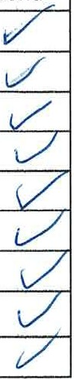FORMWORK

|  |  |  |  |
| --- | --- | --- | --- |
| Sub | | Contr | |
|  |  |  |  |
|  |  |
|  |  |
| ES | |  |
| ES | |  |
| ES | |  |
| ES | |  |
| ES | |  |
| ES | |  |

* 1. Alignment and levels checked
  2. Formwork rigid and secure
  3. Bracing complete and secure
  4. Form ties to correct layout
  5. Form ties to complete and secure
  6. Stop-ends complete
  7. Construction joints correctly positioned and complete Joint preparation complete as per specifications
  8. RETARDER SCABBLING WATERBAR
  9. Clean out complete

5.

|  |  |  |  |  |  |  |
| --- | --- | --- | --- | --- | --- | --- |
| Detailing sheet number -  Rebar Check | | | | | NIA |  |
| NIA |  |
|  | Grade Quantity | Size Laps | Cover | Welding |  |  |
| Main Rebar | MPa |  |  |  |  |  |
| Stirrups | MPa |  |  |  |  |  |
| Slab Starters | MPa |  |  |  |  |  |
| Wall Starters | MPa |  |  |  |  |  |
| Other | MPa |  |  |  |  |  |

5.1

5.2

REINFORCING St1b Contr.

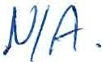

# Formwork and Rebar inspection sheet

CIVIL CONTRACTORS

10. FINAL CHECKS

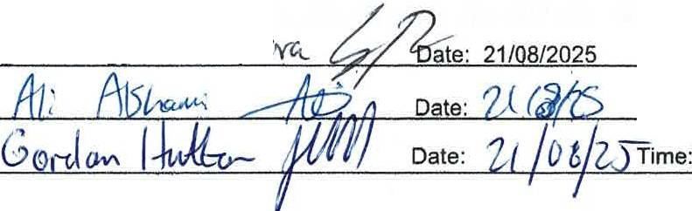

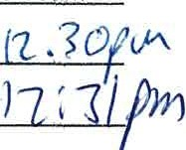Subcontractor · ' tl Time: 09.30am

Main Contr. Engineer

Time: